**VEHICLE THEFT DETECTION AND REMOTE ENGINE LOCKING**

**PROJECT REPORT**

**SUBMITTED FOR ECE 3003: MICROCONTROLLER AND ITS APPLICATIONS**

|  |  |
| --- | --- |
|  | by |
|  |  |
| **ASHUTOSH MOHAPATRA** | ++ **18BLC1035** |
| **PRANAV GUPTA** | **18BEC1050** |
| **TEJAS MUNDADA** | **18BLC1154** |

A project report submitted to:

**SLOT: D2**

**NAME OF THE FACULTY: PROF. PRAKASH V**





**June 2020**

**CONTENT**

|  |  |  |
| --- | --- | --- |
| S.No | Content | Page |
|  |  | No. |
|  |  |  |
| 1. | Certificate | 2 |
|  |  |  |
| 2. | Acknowledgement | 3 |
|  |  |  |
| 3. | Abstract | 4 |
|  |  |  |
| 4. | Introduction | 5 |
|  |  |  |
| 5. | Circuit Diagram | 6 |
|  |  |  |
| 6. | Components Description | 7 |
|  |  |  |
| 7. | Working | 13 |
|  |  |  |
| 8. | Code Used | 14 |
|  |  |  |
| 9. | Advantages and Applications | 28 |
|  |  |  |
| 10. | References | 29 |
|  |  |  |

**CERTIFICATE**

This is to certify that the Project work entitled **Vehicle Theft Detection and Remote Engine Locking** that is being submitted by **Ashutosh Mohapatra(18BLC1035) , Pranav Gupta(18BEC1050)** and **Tejas Mundada(18BLC1154**) for CAL in B.TechMicrocontroller and its Applications(ECE3003) is a record of bonafide work done under my supervision. The contents of this Project work have not been submitted for any other CAL course.

Place: Chennai

Date: 5th JUNE ,2020

Group Members:

ASHUTOSH MOHAPATRA (18BLC1035)

PRANAV GUPTA(18BEC1050)

TEJAS MUNDADA (18BLC1154)

Submitted To:

PROF. PRAKASH V

**ACKNOWLEDGEMENT**

We would like to thank Prof. Prakash V for his efforts, who was always ready with a positive comment, whether it was an off-hand comment to encourage us or constructive piece of criticism. This has fueled our enthusiasm even further and encouraged us to boldly step into what was a totally dark and unexplored expanse before us.

In course of present work it has been our privilege to receive help and assistance of my friends. We take great pleasure in acknowledge our debt to them.

We wish to thank our parents for their undivided support and interest who inspired us and encouraged us to go my own way, without whom we would be unable to complete our project. Last but not the least we want to thank my friends who appreciated us for our work and motivated us and finally to God who made all the things possible.

**ABSTRACT**

The main objective of this project is to send an auto generated SMS to the owner of the vehicle about any unauthorized entry. An advantage of this project is that the owner of the vehicle can also send back the SMS, which will deactivate the motors of the vehicle.

As the crime rate is increasing day by day, vehicle theft control system is essential for every vehicle. In this project, if an unauthorized person tries to steal the vehicle, the microcontroller gets an interrupt through a switch mechanism which is connected to the system. Then, immediately it commands the GSM modem to send an SMS.

Therefore, the owner of the vehicle can know about any happening of robbery and can deactivate the motors of the vehicle. Further, this proposed system can be developed by interfacing a GPS system, which will give the exact location of the vehicle in terms of longitude and latitude and this data can be sent to the vehicle owner through an SMS who can enter these values on google maps to get the vehicle location.

Thus, these are GPS and GSM based vehicle theft control system projects. By implementing these vehicle security system projects, a vehicle can be mostly protected from thefts. In future, this anti theft system for cars will be enhanced to function as an integrated-data-security system for car communication systems. It would ensure that all the data exchanged within the vehicle and outside the vehicle is protected.

**INTRODUCTION**

At actual the present time, the rate of crime is increasing rapidly because it is a kind of evident from the fact that thefts became a matter of routine. Particularly these vehicles may incur huge losses on the part of the amount invested on these vehicles. To overcome this problem, there are numerous technologies are available in the market such as GPS, GSM and GPRS systems. In the present days, most of the vehicles are designed with GSM based vehicle theft control systems, which provides the protection from thefts even if they are parked in the parking area.

In the modern world, there are various new technologies like GPS, GSM, RFID, and Biometric Recognition. Mobile communication has been integrated into the vehicles for security purpose. In these projects [GPS technology](https://www.elprocus.com/how-gps-system-works/) is used to find the exact location of the vehicle and GSM is used to send the message to the owner of the vehicle. At once if the vehicle seems to be theft, the owner has to just send an SMS for the vehicle to stop and the doors to close trapping the thief.

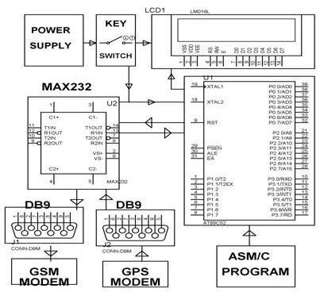

*GPS and GSM based Vehicle Theft Location Intimation Block Diagram*

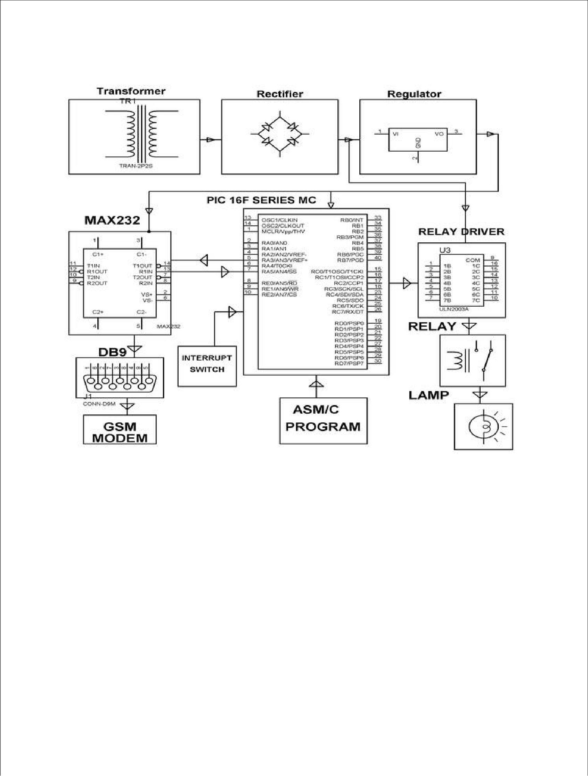

*GSM Based Vehicle Theft Intimation to the Owner on his Cell Phone using Microcontroller Block Diagram*

**CIRCUIT DIAGRAM**

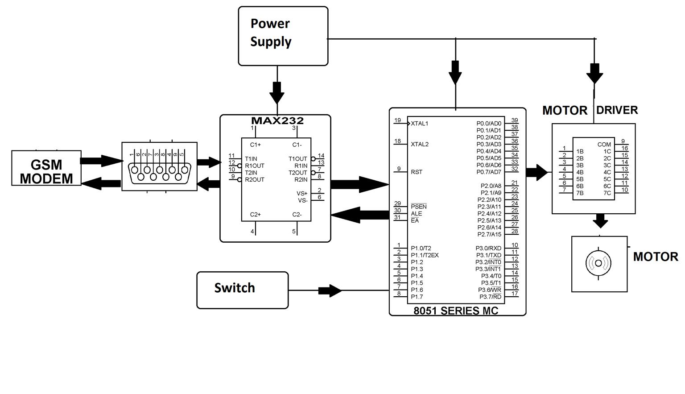

**COMPONENTS DESCRIPTION**

**1.8051(AT89S52) MICROCONTROLLER DEVELOPMENT BOARD:**

AT89S52 is used in this project. It is a micro-controller made by Atmel, having 4 input/output ports and 40 pins. Here 8051 acts as brain of our circuit. 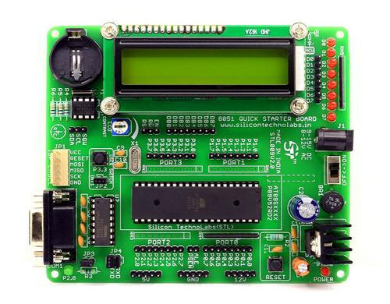It is used to display on the LCD, give commands to GSM module. A 9V battery is used to power the 8051 programmer board. Entire port2 is dedicated for LCD data transfer. RS is connected to P3.7 R/W to P3.6 and Enable to P3.5. P1.0 is the output for motor. Pins P3.0 and P3.1 are connected to txd and rxd respectively.

**2. GSM MODULE (Sim 900a):**

GSM is a mobile communication modem. It stands for global system for mobile communication (GSM). The idea of GSM was developed at Bell Laboratories in 1970. It is widely used mobile communication system in the world. GSM is an open and digital cellular technology used for transmitting mobile voice and data services operates at the 850MHz, 900MHz, 1800MHz and 1900MHz frequency bands.

The SIM900A is a complete Dual-band GSM/GPRS solution in a SMT module which can be embedded in the customer applications. Featuring an industry-standard interface, the SIM900A delivers GSM/GPRS 900/1800MHz performance for voice, SMS, Data, and Fax in a small form factor and with low power consumption. With a tiny configuration of 24mmx24mmx3mm, SIM900A can fit in almost all the space requirements in user applications, especially for slim and compact demand of design.

# **GSM Interfacing with 8051 Microcontroller**

# Mobile communication is an emerging technology these days. GSM is the acronym for Global System for Mobile Communication. GSM module is wireless modem that transmits data using radio waves. GSM architecture is similar to the mobile architecture. GSM modems are generally used in many electronic applications and they are required to interface with the microcontrollers. This article describes interfacing of a GSM modem to an AT89C51 microcontroller.

The main principle of this circuit is to interface a GSM modem with the microcontroller. The microcontroller used is AT89C51 microcontroller. To communicate with GSM modem, AT commands are required. Microcontroller sends these commands to the GSM modem, which is then activated to perform the required operation.

The following AT commands are frequently used to control the operations of GSM modem.

**Command –  Operation**

AT+CSMS    –    Select message service.

AT+CMGF   –    Message format.

AT+CMGL   –    List messages.

AT+CMGR   –    Read message.

AT+CMGS   –    Send message.

AT+CMGD   –   Delete message.

ATA              –    Answer a call.

ATD              –   Dial a number.

ATDL            –  Dial the last outgoing number.

ATH             –   Hang up the call.

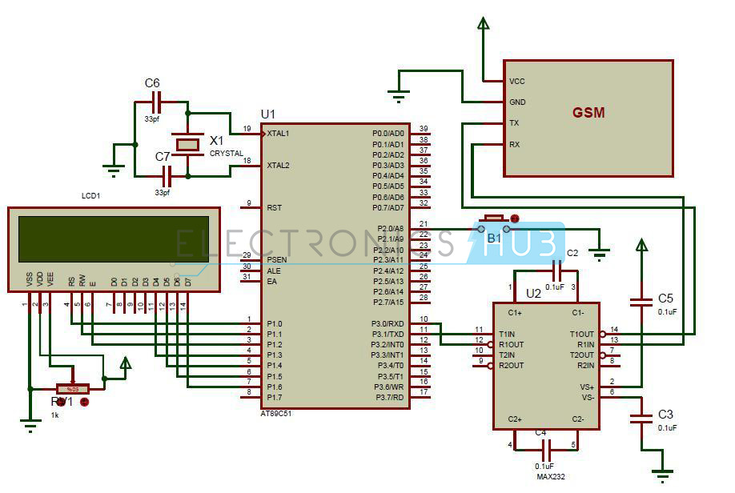

The circuit of interfacing GSM to AT89C51 microcontroller mainly consists of GSM modem and 8051 family microcontroller. GSM has RS232 interface for serial communication. In between the GSM module and the microcontroller MAX232 IC is connected.

MAX232 IC is used for converting the logic levels. RS232 logic levels of GSM are converted to the TTL logic levels of the microcontroller using this MAX232 IC. MAX232 IC has 16 pins. This is a dual driver IC as it has two transmitters and receivers. Interfacing of GSM to AT89C51 microcontroller uses only one transmitter and receiver.

The transmitter pin T1IN of max232 is connected to the transmitter pin of the microcontroller. The receiver pin R1out of the max232 is connected to the receiver pin of the microcontroller. The T1out pin of the IC is connected to the transmitter pin of the GSM modem.

The R1IN pin of the IC is connected to the receiver pin of the GSM modem. Two 0.1 micro farad capacitors are connected to the pins of 1, 2 and 4 , 5. Another 1uf capacitor is grounded from pin6 and another capacitor is connected to the supply of 5v from the through the 2nd pin of the IC.

GSM modem used here has sim300 module. These wireless modems communicate with the microcontrollers and other devices. This has 4 pins compatible to TTL logic. These can be directly connected to the microcontroller as it has max232 or use the DB9 connector to connect to the controller.

In this article, MAX232 pins are connected to the GSM modem. This should be connected to the power supply of 5v. It has a sim slot similar to a mobile to communicate with the network. GSM modem requires AT commands for activation. GSM modem responds to the AT command.

An LCD module is connected to the port2 of the microcontroller. This article also shows the interfacing of 4-bit LCD module to the microcontroller. Data bits D4-D7 of the LCD module are connected to the port2 of the microcontroller. A pot is connected to the LCD to adjust the intensity of the display. Here LCD is used for displaying the received message.

A button is connected to the PORTB of the microcontroller. This button is used for sending a message.

How to Operate GSM Interfacing with 8051 Microcontroller Circuit?

Initially, connect the circuit as shown in the circuit diagram.

Switch on the power supply.

Now send a message from any other phone to the SIM present in the GSM module.

Whenever a message is received by the GSM, it is displayed on the LCD.

If you want to send a message press the button B1 connected to port B.

This sends a message written in the code.

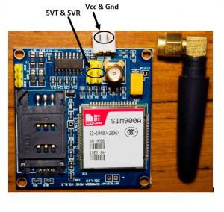

**4. 9V BATTERY:**

The nine-volt battery, or 9-volt battery, is a common size of battery that was introduced for the early [transistor radios.](https://en.wikipedia.org/wiki/Transistor_radio) It has a rectangular prism shape with rounded edges and a polarized snap connector at the top. This type is commonly used in [walkie-talkies,](https://en.wikipedia.org/wiki/Walkie-talkie) [clocks](https://en.wikipedia.org/wiki/Clock) and [smoke detectors.](https://en.wikipedia.org/wiki/Smoke_detector)

The nine-volt battery format is commonly available in primary carbon-zinc and alkaline chemistry, in primary lithium iron disulfide, and in rechargeable form in nickel-cadmium, nickel-metal hydride and lithium-ion. Mercury-oxide batteries of this format, once common, have not been manufactured in many years due to their mercury content. [Designations](https://en.wikipedia.org/wiki/Battery_nomenclature) for this format include *NEDA 1604* and *IEC 6F22* (for zinc-carbon) or *MN1604 6LR61* (for alkaline). The size, regardless of chemistry, is commonly designated PP3—a designation originally reserved solely for carbon-zinc, or in some countries, *E* or *E-block*.

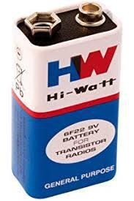

**KEIL µ VISION IDE:**

The µVision IDE combines project management, run-time environment, build facilities, source code editing, and program debugging in a single powerful environment. µVision is easy-to-use and accelerates your embedded software development. µVision supports multiple screens and allows you to create individual window layouts anywhere on the visual surface.

The [µVision Debugger](http://www.keil.com/mdk5/debug) provides a single environment in which you may test, verify, and optimize your application code. The debugger includes traditional features like simple and complex breakpoints, watch windows, and execution control and provides full visibility to device peripherals.



**WORKING**

In this proposed work, a novel method of vehicle tracking and locking system is used to track the theft vehicle by using GPS and GSM technology. This system is put into sleep mode while the vehicle is handled by the owner or authorized person otherwise goes to active mode, the mode of operation can be changed by the user. If the ignition button of the car is pressed while the system is in theft mode, the controller issues the message about the theft of the vehicle to the car owner or authorized person. When the user sends a message back to the micro-controller, the motor is stopped. Thereby keeping a check on unauthorized access of the car.

Here, the MAX232 acts as an interface between the microcontroller and the GSM modem.

The MAX232 acts as an interface between the GSM modem and the microcontroller to change the TTL signals to RS232 signals. The microcontroller acts a heart of the owl system that accepts the signals from these sensors and sends the signals to the GSM modem and alerts the buzzer. Then, sends that information to the owner of the car.

**CODE**

org 0000h

init_serial: mov scon,#50h

mov tmod,#21h

mov tl1,#0fdh

mov th1,#0fdh

setb tr1

main: mov p0,#00h

clr p0.1

acall lcdi

acall init_gsm

display1: mov dptr,#table

mov r7,#05h

mov r0,#00h

backdis1: mov a,r0

movc a,@a+dptr

acall lcddata

inc r0

djnz r7,backdis1

acall send_gsm1

acall recieve

display2: mov a,#0c0h

acall lcdcmd

mov dptr,#table1

mov r7,#05h

mov r0,#00h

backdis2: mov a,r0

movc a,@a+dptr

acall lcddata

inc r0

djnz r7,backdis2

setb p0.1

hereyo: sjmp hereyo

send: mov sbuf,a

waits: jnb ti,waits

clr ti

ret

recieve: acall init_gsmr

acall delay

waitr: jnb ri,waitr

mov a,sbuf

clr ri

ret

timer0: mov tl0,#00h

mov th0,#00h

setb tr0

waitt0: jnb tf0,waitt0

clr tr0

clr tf0

ret

delay: mov r1,#7h

backd: acall timer0

djnz r1,backd

ret

lcdi: mov a,#38h

acall lcdcmd

acall delay

mov a,#0eh

acall lcdcmd

acall delay

mov a,#01h

acall lcdcmd

acall delay

mov a,#06h

acall lcdcmd

acall delay

mov a,#80h

acall lcdcmd

acall delay

ret

lcdcmd: mov p2,a

clr p3.7

clr p3.6

setb p3.5

acall delay

clr p3.5

acall delay

ret

lcddata: mov p2,a

setb p3.7

clr p3.6

setb p3.5

acall delay

clr p3.5

acall delay

ret

init_gsm: MOV A,#"A"

ACALL SEND

MOV A,#"T"

ACALL SEND

MOV A,#0DH

ACALL SEND

ACALL DELAY

MOV A,#"A"

ACALL SEND

MOV A,#"T"

ACALL SEND

MOV A,#"+"

ACALL SEND

MOV A,#"C"

ACALL SEND

MOV A,#"M"

ACALL SEND

MOV A,#"G"

ACALL SEND

MOV A,#"F"

ACALL SEND

MOV A,#"="

ACALL SEND

MOV A,#"1"

ACALL SEND

MOV A,#0DH

ACALL SEND

ACALL DELAY

MOV A,#"A"

ACALL SEND

MOV A,#"T"

ACALL SEND

MOV A,#"+"

ACALL SEND

MOV A,#"C"

ACALL SEND

MOV A,#"M"

ACALL SEND

MOV A,#"G"

ACALL SEND

MOV A,#"S"

ACALL SEND

MOV A,#"="

ACALL SEND

MOV A,#34D

ACALL SEND

MOV A,#"+"

ACALL SEND

MOV A,#"9"

ACALL SEND

MOV A,#"1"

ACALL SEND

MOV A,#"8"

ACALL SEND

MOV A,#"2"

ACALL SEND

MOV A,#"9"

ACALL SEND

MOV A,#"9"

ACALL SEND

MOV A,#"0"

ACALL SEND

MOV A,#"7"

ACALL SEND

MOV A,#"6"

ACALL SEND

MOV A,#"7"

ACALL SEND

MOV A,#"5"

ACALL SEND

MOV A,#"7"

ACALL SEND

MOV A,#34D

ACALL SEND

MOV A,#0DH

ACALL SEND

ACALL DELAY

ret

init_gsmr: mov a,"A"

ACALL SEND

MOV A,#"T"

ACALL SEND

MOV A,#"+"

ACALL SEND

MOV A,#"C"

ACALL SEND

MOV A,#"N"

ACALL SEND

MOV A,#"M"

ACALL SEND

MOV A,#"I"

ACALL SEND

MOV A,#"="

ACALL SEND

MOV A,#"2"

ACALL SEND

MOV A,#","

ACALL SEND

MOV A,#"2"

ACALL SEND

MOV A,#","

ACALL SEND

MOV A,#"0"

ACALL SEND

MOV A,#","

ACALL SEND

MOV A,#"0"

ACALL SEND

MOV A,#","

ACALL SEND

MOV A,#"0"

ACALL SEND

ACALL DELAY

RET

SEND_GSM1: MOV A,#"T"

ACALL SEND

MOV A,#"H"

ACALL SEND

MOV A,#"E"

ACALL SEND

MOV A,#"F"

ACALL SEND

MOV A,#"T"

ACALL SEND

ACALL DELAY

MOV A,#1AH

ACALL SEND

ret

org 0400h

table: db 'Theft',0

table1: db 'stopp',0

endhere: sjmp endhere

end

**PROS AND CONS**

1. User can know about the theft almost immediately.
2. User can revert back and stop the car at their will.
3. This project can be used in various places, with slight modifications.
4. Easy to steal the car if the user is not able to access their phone.
5. Can’t get exact details of location only using GSM module.
6. Although GSM has many advantages there are some limitations. This cannot be used in applications where immediate result is required as it may not work if there are no signals.

**REFERENCES**

1- [https://nevonprojects.com](https://nevonprojects.com/)

2- [https://www.elprocus.com](https://www.elprocus.com/)

3- [https://www.projectsof8051.com](https://www.projectsof8051.com/)

4- <https://www.youtube.com/>

5- <https://www.google.com/>